Yazhuo Liu

Homework 1

1. Output:
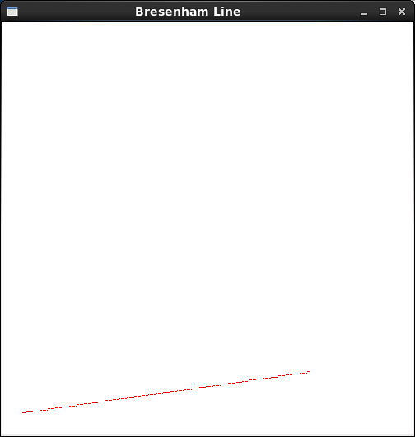
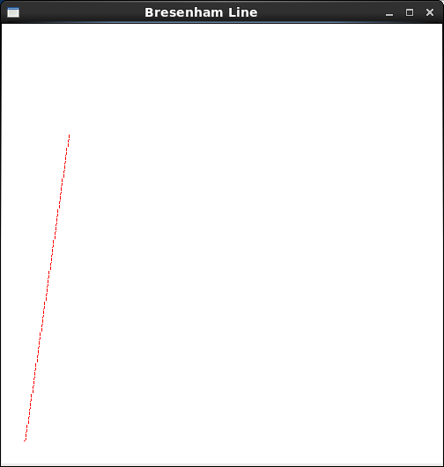

(20, 20) – (300, 60) (20, 20) – (60, 300)

Partial code:
...
void line()
{
int x0 = 20, y0= 20, xn = 300, yn = 60, x, y;
int dx, dy, //deltas
pk, //decision parameter
k; //looping variable

glClear(GL_COLOR_BUFFER_BIT);
glColor3f( 1, 0, 0 );
setPixel(x0, y0); //plot first point

// difference between starting and ending points
dx = xn - x0;
dy = yn - y0;
pk = 2 * dy - dx;
x = x0; y = y0;
double m = dy / dx;

if (m <= 1 && m >= -1) {
for ( k = 0; k < dx-1; ++k ) {
if ( pk < 0 ) {
pk = pk + 2 * dy; //calculate next pk
//next pixel: (x+1, y )
} else {
//next pixel: (x+1, y+1)
pk = pk + 2*dy - 2*dx; //calculate next pk
++y;
}
++x;
setPixel( x, y );
}
}
else if (m > 1 || m < -1) {
for ( k = 0; k < dy-1; ++k ) {
if ( pk < 0 ) {
pk = pk + 2 * dx; //calculate next pk
//next pixel: (x+1, y )
} else {
//next pixel: (x+1, y+1)
pk = pk + 2*dx - 2*dy; //calculate next pk
++x;
}
++y;
setPixel( x, y );
}
}
glFlush();
}
...

2. Output:
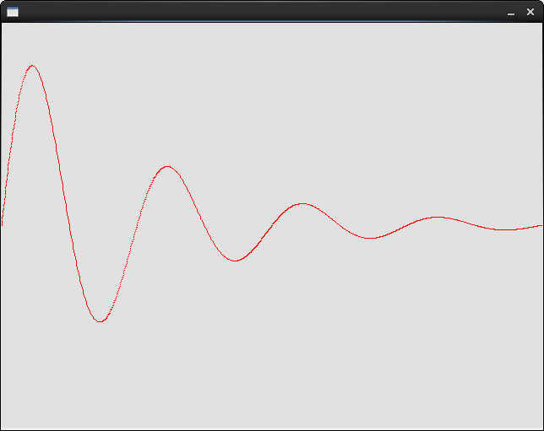

f(x) = e-|x| sin ( 2π x )
Partial code:
...
double f ( double x )
{
double y = exp ( -fabs ( x ) ) * sin ( 2 * 3.1415926 * x );

return y;
}

int main()
{
const int VWIDTH = 640;
const int VHEIGHT = 480;

const Point center ( VWIDTH/2, VHEIGHT/2 ); //center of screen
Surface surf( VWIDTH, VHEIGHT, (char *) "draw_line" );

surf.clearScreen(); //clear screen
surf.updateSurface();
// SDL_Delay ( 1000 ); //dealy one second, just for demo

surf.setBackgroundColor ( 0xe0, 0xe0, 0xe0 ); //set background to grey

//draw a line
surf.setColor ( 0xff, 0, 0 ); //using red color

int sx, sy;
double x, y, a, b, c, d;
a = VWIDTH / 4.0;
c = 0;
b = -VHEIGHT / 2.0;
d = VHEIGHT / 2.0;

x = 0.0; //initial position
y = f ( 0.0 );
sx = (int) ( a * x + c );
sy = (int) ( b * y + d );
surf.moveTo ( sx, sy );

for ( x = 0; x < 4.0; x += 0.005 ) {
y = f ( x );
sx = (int) ( a * x + c );
sy = (int) ( b * y + d );
surf.lineTo ( sx, sy );
}
...

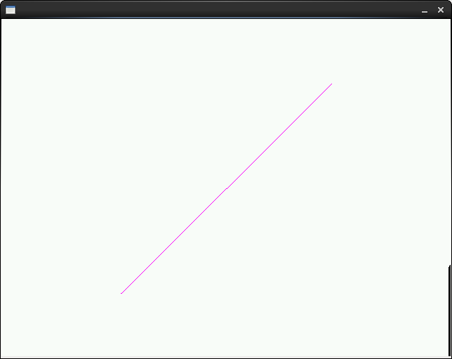
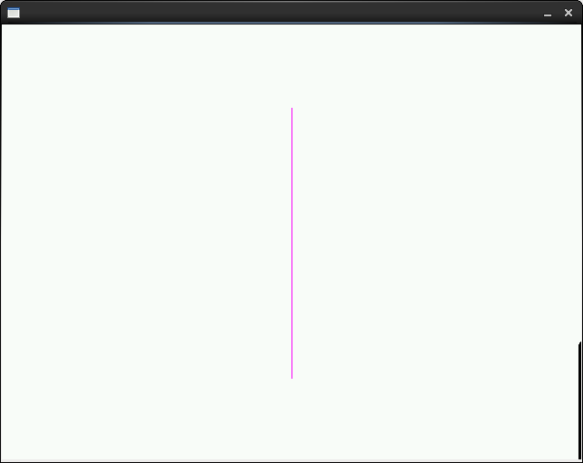
3. Output:
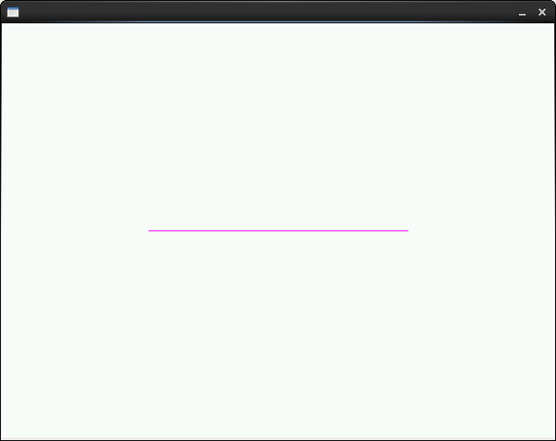
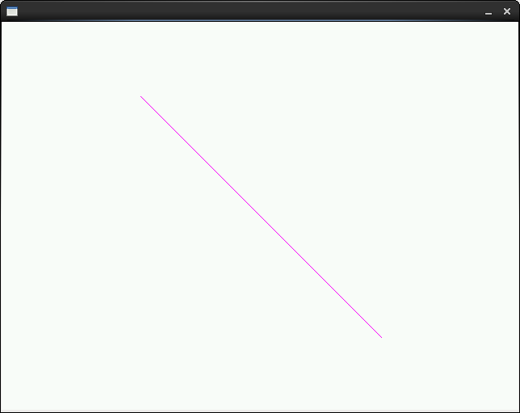

Code:
...
surf.setColor (0xff, 0, 0xff);
surf.moveTo (center.x - 150, center.y);
surf.forward (300, 1);

surf.updateSurface();
SDL_Delay ( 2000 );
surf.clearScreen();

surf.moveTo (center.x - 150, center.y + 150);
surf.lineTo (center.x + 150, center.y - 150);

surf.updateSurface();
SDL_Delay ( 2000 );
surf.clearScreen();

surf.moveTo (center.x, center.y + 150);
surf.lineTo (center.x, center.y - 150);

surf.updateSurface();
SDL_Delay ( 2000 );
surf.clearScreen();

surf.moveTo (center.x + 150, center.y + 150);
surf.lineTo (center.x - 150, center.y - 150);

surf.updateSurface();
SDL_Delay ( 2000 );
surf.clearScreen();

surf.moveTo (center.x - 150, center.y);
surf.forward (300, 1);
...

4. Output:
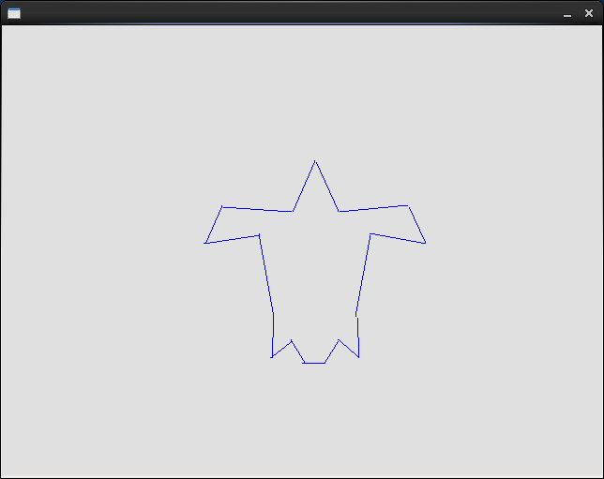
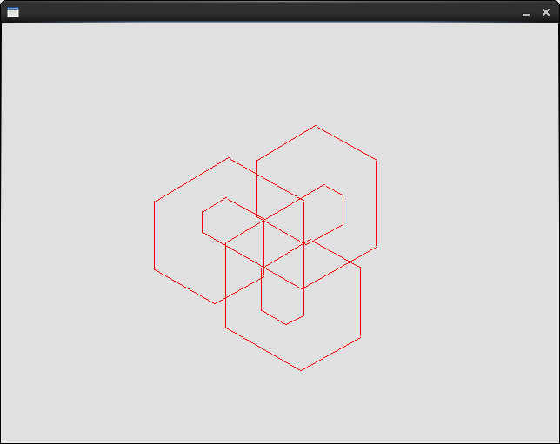

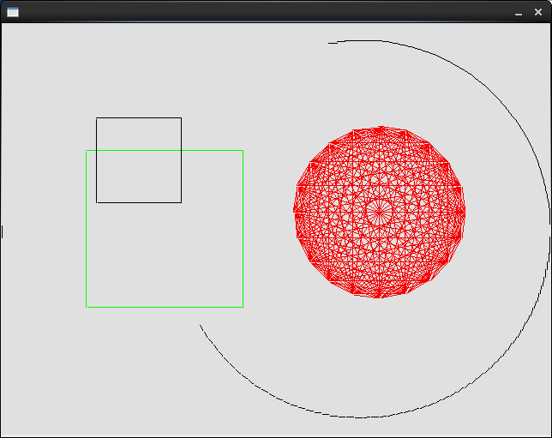
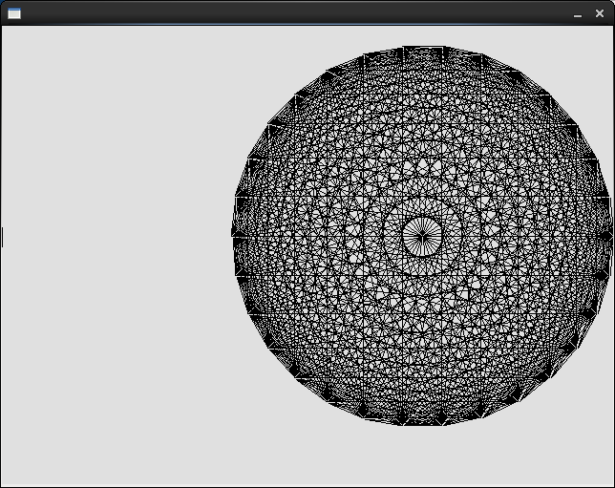

Code:
...
void draw_no_3 (Surface &surf, int L)
{
surf.turn( 330 );
surf.forward( L/3*4, 1 );
surf.turn( 60 );
surf.forward( L, 1 );
surf.turn( 60 );
surf.forward( L, 1 );
surf.turn( 60 );
surf.forward( L/6*5, 1 );
surf.turn( 60 );
surf.forward( L/6*5, 1 );
surf.turn( 60 );
surf.forward( L/3*2, 1 );
surf.turn( 60 );
surf.forward( L/3*2, 1 );
surf.turn( 60 );
surf.forward( L/2, 1 );
surf.turn( 60 );
surf.forward( L/3, 1 );
surf.turn( 60 );
surf.forward( L/4, 1 );
surf.turn( 60 );
}

void draw_3(Surface & surf, int L)
{
draw_no_3( surf, L );
surf.turn( 30 );
draw_no_3( surf, L );
surf.turn( 30 );
draw_no_3( surf, L );
}

//draw turtle 1
void draw_turtle1( Surface & surf, int L)
{
surf.forward( L * 0.8, 1 );
surf.turn( 60 );
surf.forward( L, 1 );
surf.turn( 260 );
surf.forward( L, 1 );
surf.turn( 135 );
surf.forward( L * 1.5, 1 );
surf.turn( 345 );
surf.forward( L * 3, 1 );
surf.turn( 270 );
surf.forward( L * 2, 1 );
surf.turn( 125 );
surf.forward( L * 1.5, 1 );
surf.turn( 70 );
surf.forward( L * 2.5, 1 );
surf.turn( 290 );
surf.forward( L * 2, 1 );
surf.turn( 130 );
surf.forward( L * 2, 1 );
surf.turn( 290 );
surf.forward( L * 2.5, 1 );
surf.turn( 70 );
surf.forward( L * 1.5, 1 );
surf.turn( 125 );
surf.forward( L * 2, 1 );
surf.turn( 270 );
surf.forward( L * 3, 1 );
surf.turn( 345 );
surf.forward( L * 1.5, 1 );
surf.turn( 135 );
surf.forward( L, 1 );
surf.turn( 260 );
surf.forward( L, 1 );
surf.turn( 60 );
}

//draw rosette with N-sided polygon
void rosette (Surface &surf, int N, int radius )
{
if ( N < 3 ) return;
Point pt[N+1];

int cx = surf.getCP().x;
int cy = surf.getCP().y;
double angle = 0; //initial angle
double angleInc = 2 * 3.14159265 / N; //angle increment
pt[0] = Point ( ( int) (radius * cos( angle ) + cx),
( int ) ( radius * sin ( angle ) + cy ) );
for ( int k = 1; k < N; k++ ) { //repeat n times
angle += angleInc;
pt[k] = Point ( ( int) (radius * cos( angle ) + cx),
( int ) ( radius * sin ( angle ) + cy ) );
}
for ( int i = 0; i < N - 1; i++ ) {
for ( int j = i + 1; j < N; j++ ) {
surf.moveTo ( pt[i] ); //connect all vertices
surf.lineTo ( pt[j] );
}
}
} //rosette
...

//draw an arc
surf.setColor (0, 0, 0);
surf.moveTo (center.x + 100, center.y);
draw_arc ( surf, 100, 220, 260, 250 );

//draw a big square
surf.setColor (0, 0xff, 0);
surf.moveTo (center.x - 130, center.y);
draw_polygon (surf, 4, 130, 45);

//draw a small square
surf.setColor (0, 0, 0);
surf.moveTo (center.x - 160, center.y - 80);
draw_polygon (surf, 4, 70, 45);

//draw an 8-sided rosette
surf.setColor ( 0xff, 0, 0 ); //using black color
surf.moveTo ( center.x + 120, center.y - 20 );
rosette ( surf, 20, 100 );
...

Report:
The homework problems are pretty hard for me to do. I don't even think I can complete it. I did my best but I couldn't really understand the materials taught in class. Part one of the homework I got a and b, but have troubles doing c and d. Part two I did it but I don't think I really understood what the question is asking. Part three I feel I did well, I successfully animated the rotation of the line. Part four is the most difficult one, I could only do four images. I feel like the homework is so much harder than the labs, especially when doing it without any help.

